**Project : Capstone I**

You have been hired as a Sr. DevOps Engineer in Abode Software. They want to

implement DevOps Lifecycle in their company. You have been asked to

implement this lifecycle as fast as possible. Abode Software is a product-based

company and their product is available on this GitHub link.

<https://github.com/hshar/website.git>

Following are the specifications of the lifecycle:

1. Install the necessary software on the machines using a configuration

management tool

2. Git workflow has to be implemented

3. CodeBuild should automatically be triggered once a commit is made to

master branch or develop branch.

a. If a commit is made to master branch, test and push to prod

b. If a commit is made to develop branch, just test the product, do not

push to prod

4. The code should be containerized with the help of a Dockerfile. The

Dockerfile should be built every time there is a push to GitHub. Use the

following pre-built container for your application: hshar/webapp

The code should reside in '/var/www/html'

5. The above tasks should be defined in a Jenkins Pipeline with the following

jobs:

a. Job1 : build

b. Job2 : test

c. Job3 : prod

Solution:-

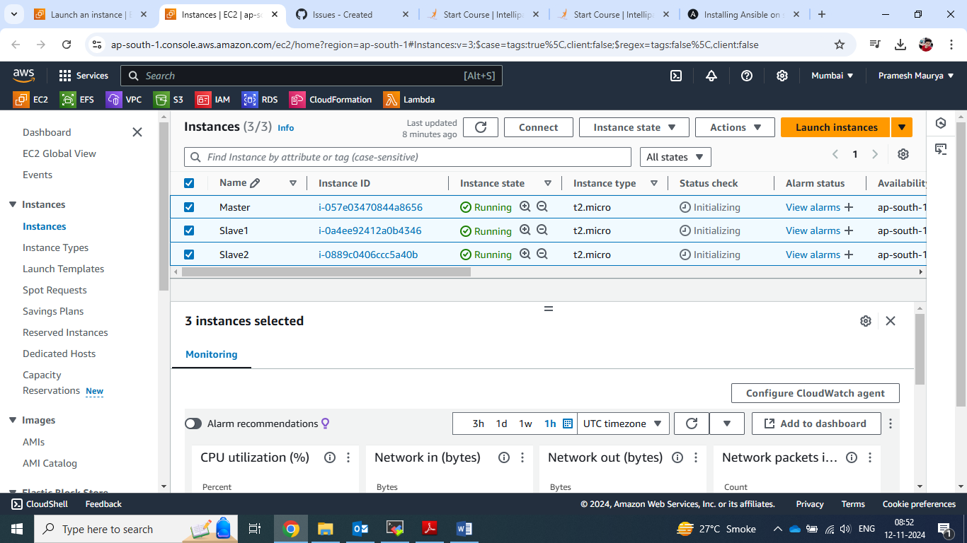

1. As per project have created 3 machine.

2 . Installing ansible on master machine.

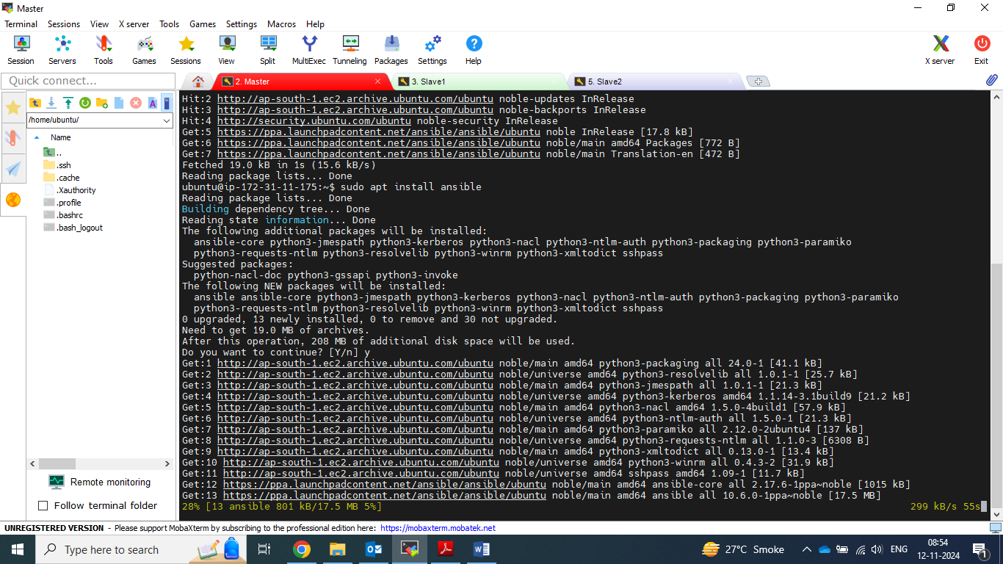

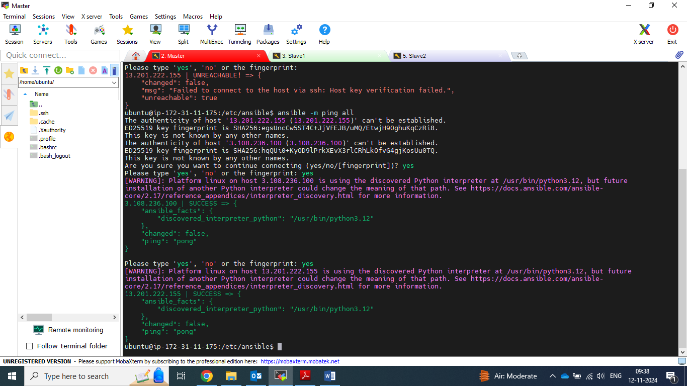

3.ssh connection made between master and slave.

4. created file play.yml for master and slave file configuration.

5. master.sh file configuration.

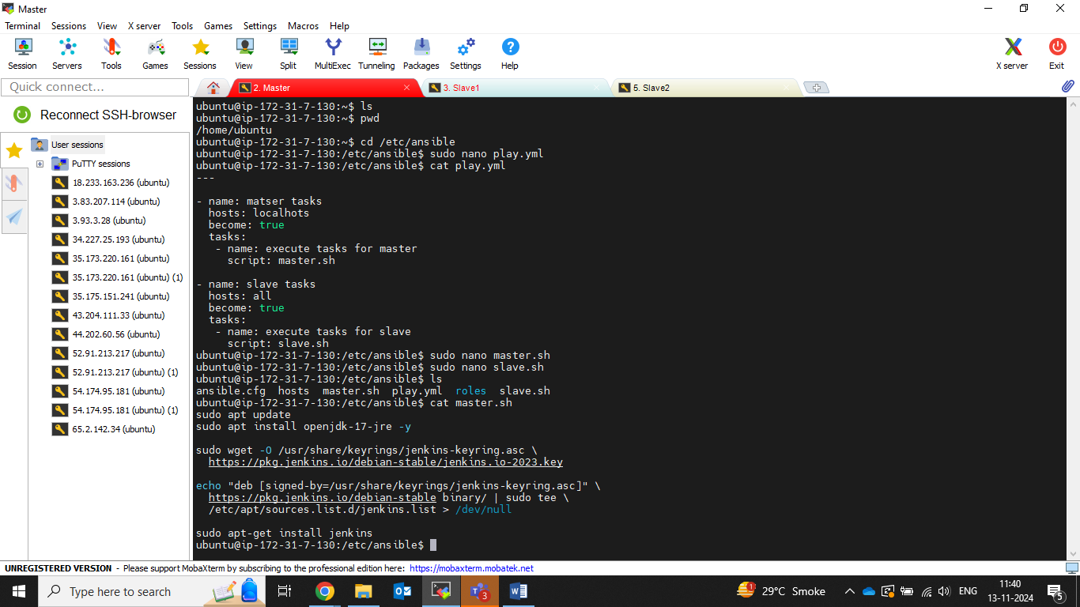

6. slave.sh file configuration .

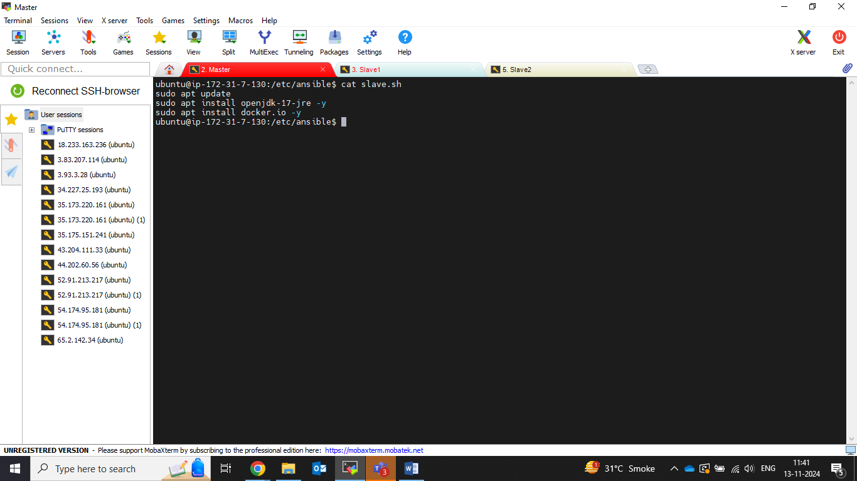

7. Run play.yml file which has been run successfully.

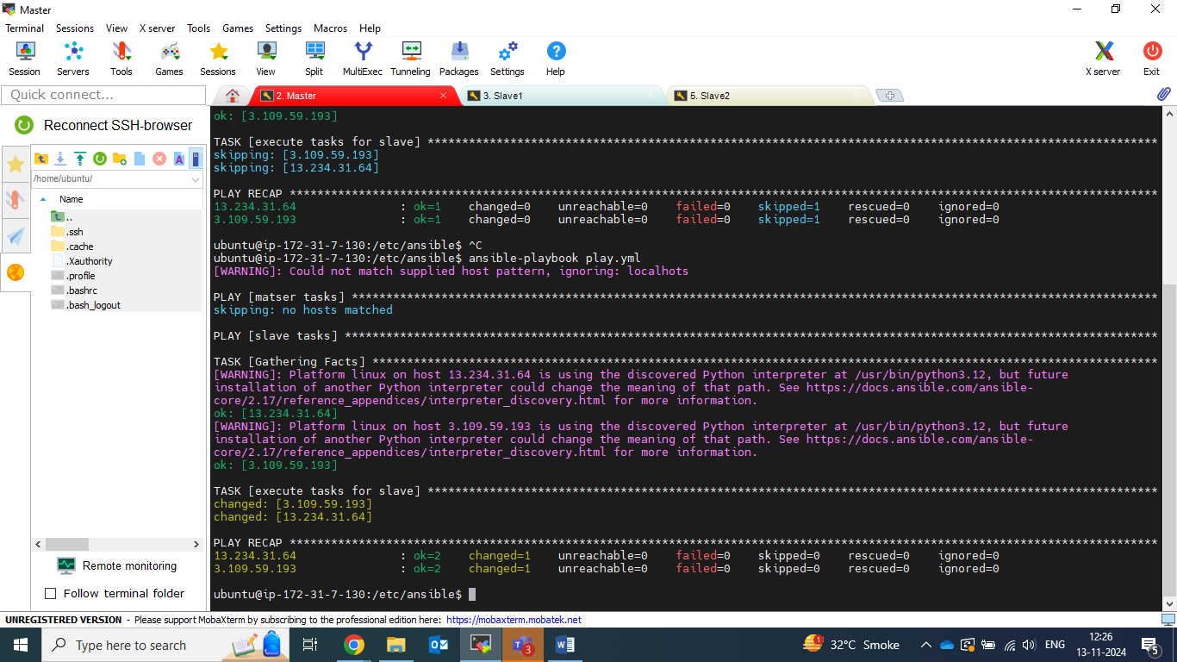

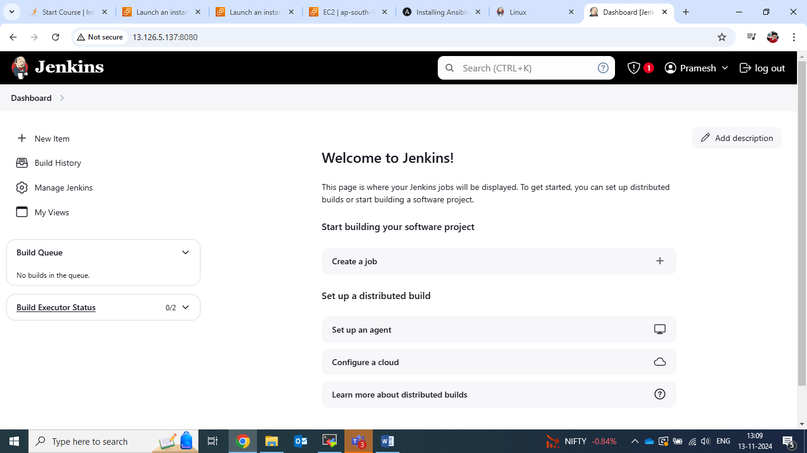

8. Now started Jenkins.

9. Configuring salve1 node into Jenkins server.

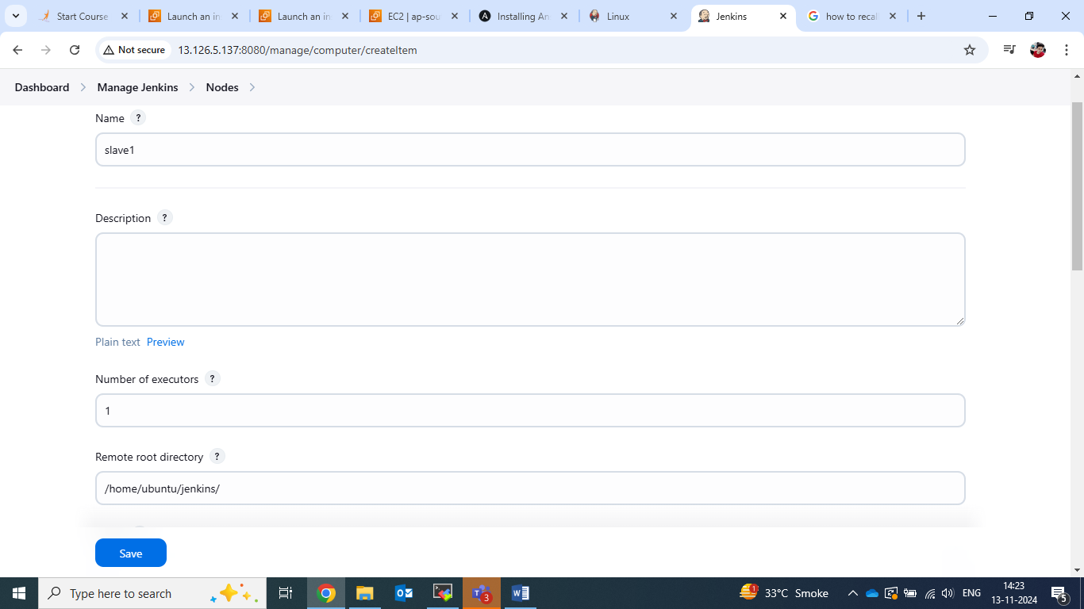

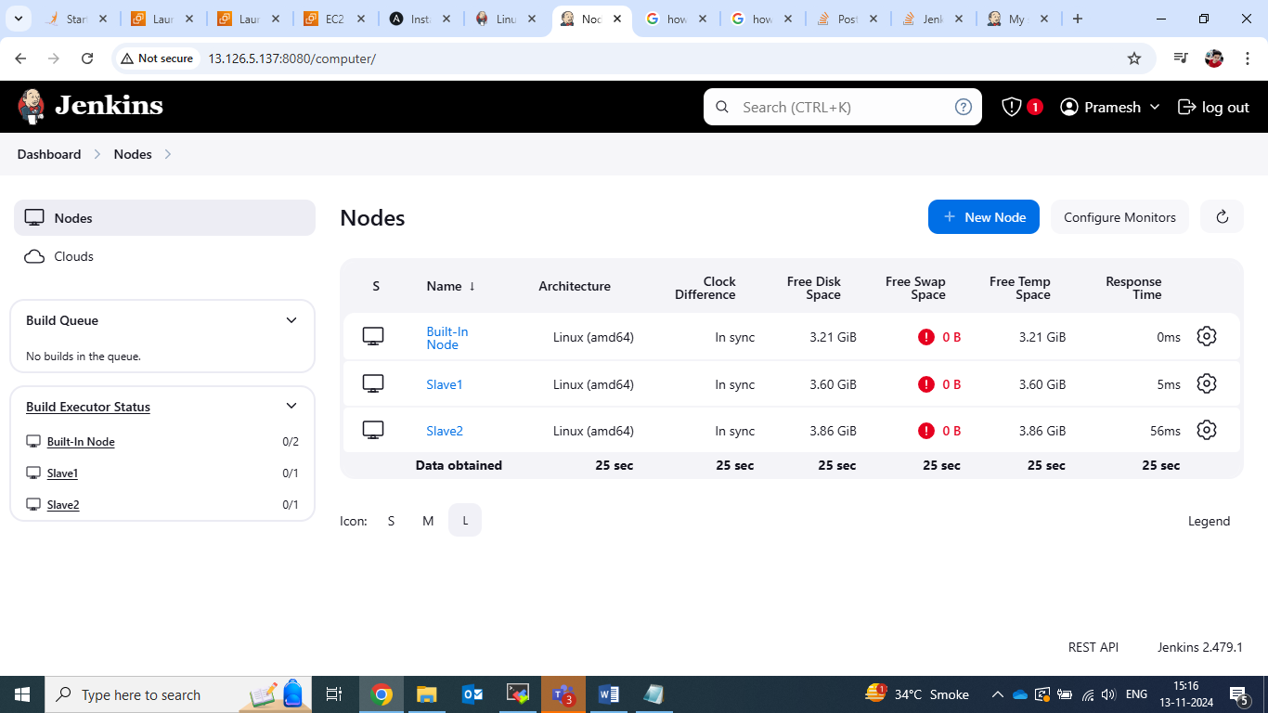

10. Both salve node configure and connected.

11. Now created new repository on GitHub with name of 13-nov.

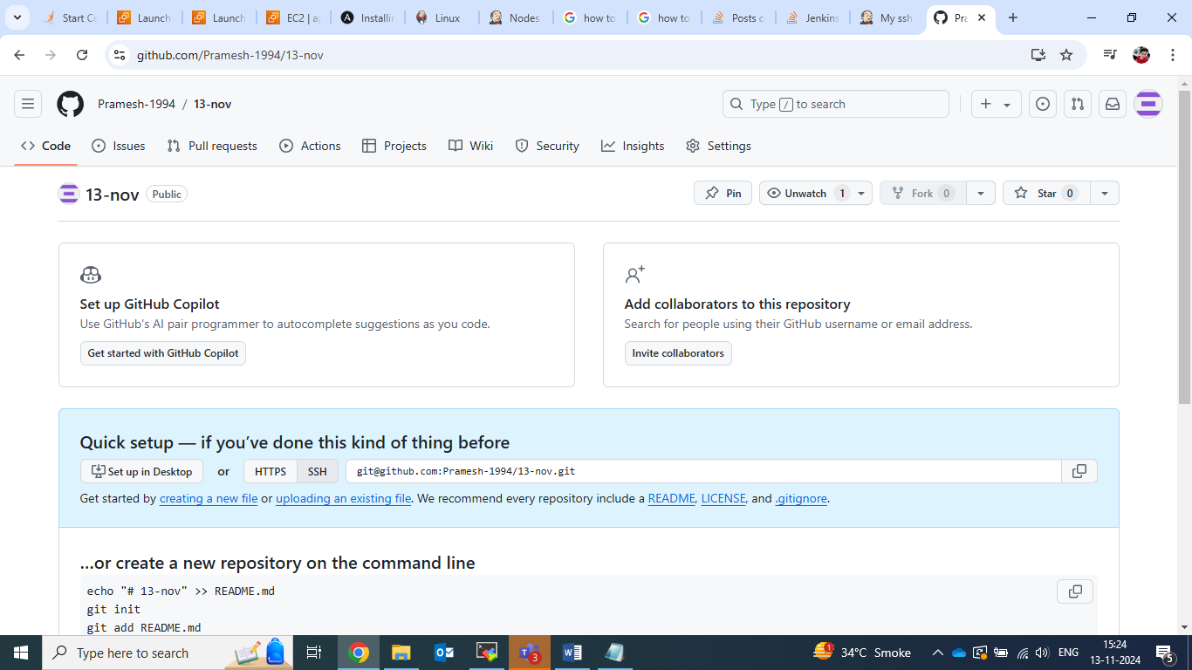

12. Now created develop branch on GitHub

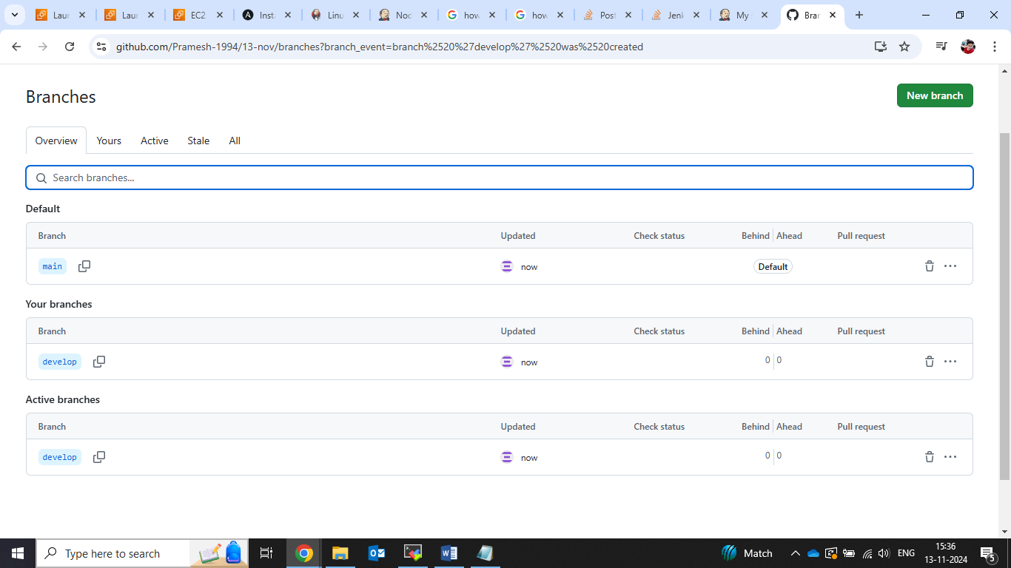

13. job2 which has build successfully on slave1 .

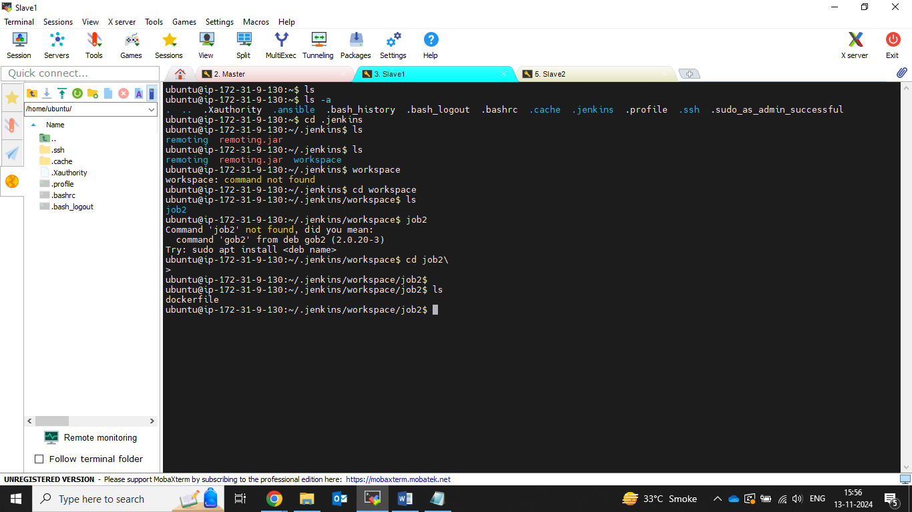

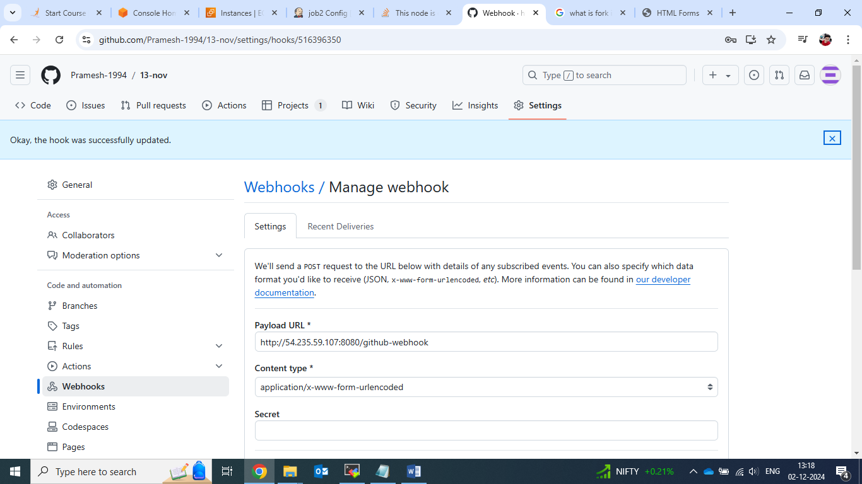

14. webhook configured.

15. docker code build setup in job 2 .

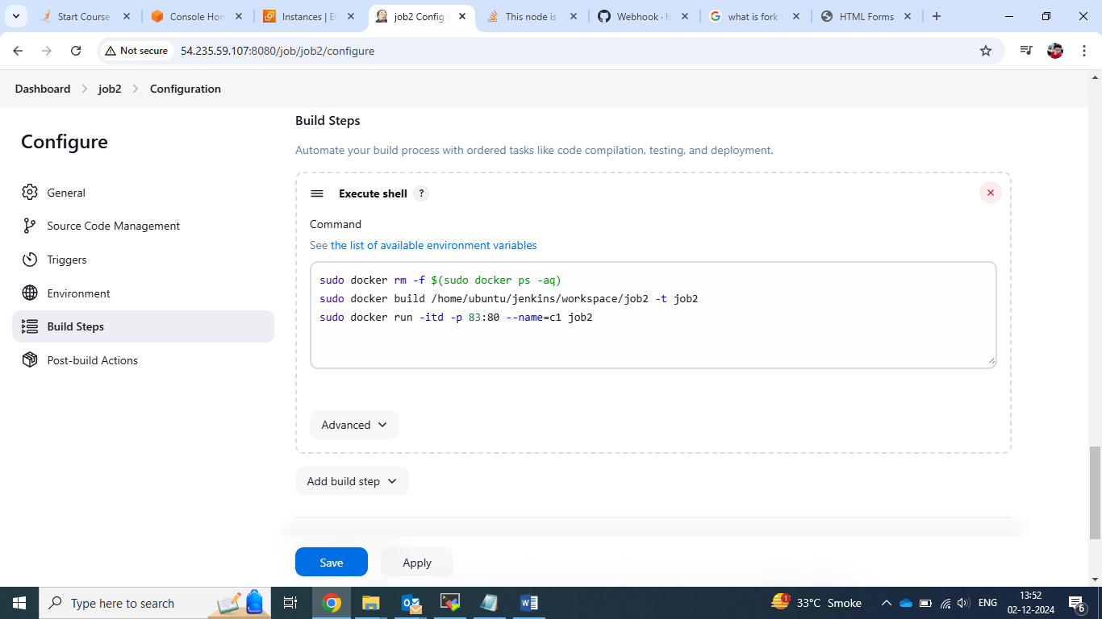

16. job2 build successfully.

